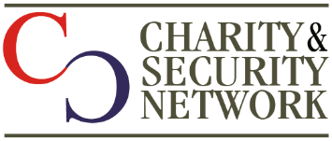

700 12th St NW, Suite 700, Washington, DC 20005
202 481 6927

Join the Charity & Security Network 2020
Organizations joining the Charity & Security Network will be:
- Listed on our website and at special events (optional)
- Consulted on a semi-annual basis to provide input on trends, priorities and needs
- Have the opportunity to participate in Working Groups and Network projects
Sliding Scale Dues are based on annual budget:
Annual Budget | 2020 Dues
Up to $1 Million | $500
$1 Million to $2.5 Million | $1,000
$2.5 Million to $5 Million | $2,000
$5 Million to $10 Million | $3,000
$10 Million to $20 Million | $4,000
$20 Million and above | $5,000

The Charity & Security Network is a project of NEO Philanthropy, a 501(c)(3) organization. Please make out checks to NEO Philanthropy and note the Charity & Security Network project on the memo line.

Please fill in the form below and mail to:
Kay Guinane, Director, Charity & Security Network 1101 14th St NW, Suite 1400, Washington, DC 20005

Dues can be paid online using our donate page here: https://donatenow.networkforgood.org/charitysecuritynetwork

Organization_______________________________
Contact Person: _______________________________

Email_____________________________________
Address___________________________________ Phone_____________________________________
Amount:_____________________________ Listed on website: ____Yes ____No

TOTAL ENCLOSED:______________________

